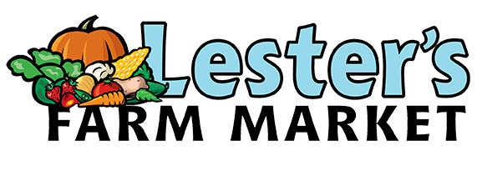
Craft Fair Application 2022
Saturday, August 27, 2022 10:00am-4:00pm, Saturday, November 5, 2022 9:30am-4:00pm
Saturday December 3, 2022 9:30am-4:00pm
Contact Name: ________________________________________________________________
Contact Number: ______________________________________________________________
E-mail: _______________________________________________________________________
Name of Business/Vendor: _______________________________________________________
Description of Vendor/Crafts for sale: _________________________________________________________
_________________________________________________________________________________________
_________________________________________________________________________________________
Price Range: ___________________________________________________________________
Facebook/Social Media page for Craft/vendor: _______________________________________
Dates Interested in: _____________________________________________________________
Space Needed: _________________________________________________________________
Special Requests (please note all requests may not be possible): _____________________________
Forms of Payment Accepted: _____________________________________________________
Note: A 6 or 8ft table is provided to vendors, there is a fee of $40 per table. If more than one table is needed, please let us know in the space above. Only one vendor/business per table please. Craft fairs are held in our greenhouses.
Please note we have many vendors looking for space at our craft fairs, due to the limited space we may not be able to accommodate everyone. We will let you know if you do have a table at our craft fair by August 13 for our August fair and by October 12, 2022 for the November/December dates.
Please return application no later than October 10, 2022.
Applications can be passed into Lester’s Farm Market at 173 Brookfield Rd St. John’s NL
Or submitted through our online form.

